
NOIS

Department of Veterans Affairs
National Online Information Sharing
Training Examples
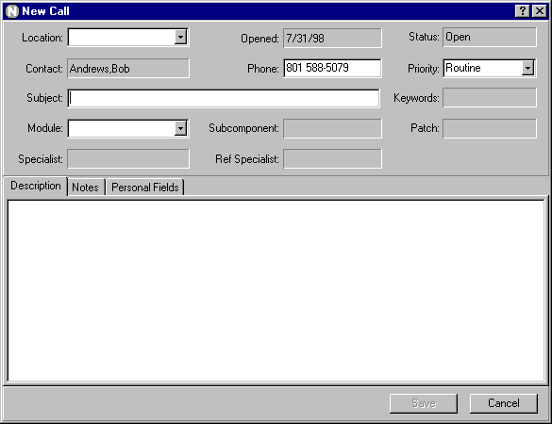
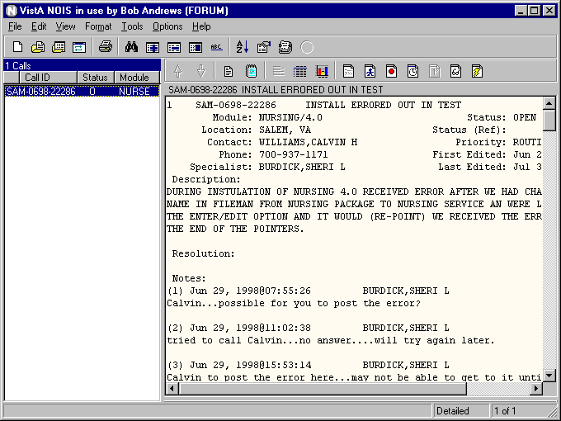
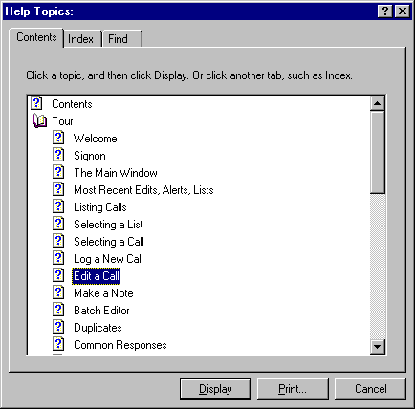
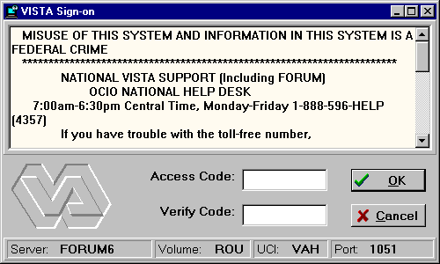

Getting Started

Welcome

NOIS is National Online Information SHARING. NOIS provides a way of tracking requests for service from all VA locations. The information in NOIS can be accessed by nearly any Forum user. If you have never used it before, you can access it by typing in NOIS on any menu on Forum. This will give you access to the character-based version that uses List Manager.You can enter a request (a NOIS call) and review anyone elses calls. The new version of NOIS uses a graphical user interface (GUI) to access Forum. This is a Windows program that communicates with Forum over a network connection. This version is available to any Forum user by downloading it from the anonymous software directory. This training will assume you have access to Forum and have the NOIS GUI installed on your PC.

NOIS (List Manager and GUI) can also be installed and used at a local facility.

If you are a new user to NOIS please review this handout. If you have been using NOIS already, refer to the handouts for the type of user you are: Support Specialist, Referral Specialist, IRM, ADPAC, or someone who analyses NOIS information.

The NOIS Process

It doesn't make a difference whether you make a request by entering it directly into NOIS on FORUM or by calling a National Help Desk.

BRX-10/95-12345
Call Number.
Assigned automatically by the NOIS software.

Site Abbreviation

Month / Year
that call was opened

The moment the call is entered into NOIS, an alert will go to all the members of the appropriate customer service team (AVANTI, AXP, Clin1, Clin2, MCM, PIMS or Fiscal Management). At this point the status of the call is OPEN. If you entered the call yourself or were put in as the contact, you will also receive alerts when any action is taken on the call.

You can review the NOIS call at any time by looking up the call. You can do this by using menus that retain your most recently edited calls, looking at a list that contains the call, or by directly looking up the call.

A Customer Service Specialist will "pick up" (claim) the call and call the site contact within 2 hours in most cases. If this initial call back provides the solution, the call will be closed at that time. If the Customer Service person needs more information, they will ask for it. They may ask to have a conference call with the ADPAC, end users and the IRM Staff involved in solving the problem at the local site. If at any time, you want to add information, you can make a note to the call; an alert will be sent immediately to the "NOIS specialist" working on the call.

At any point — you can check the STATUS of the call. NOIS has two fields for checking the status. Status and Status (REF). At the time you open the call, the STATUS is set to open. Customer Support specialists are working on the problem. If they resolve the problem, they will CLOSE the call, and the status is set to closed. If the call is entered in error, someone will cancel the call and the status will be changed to X, which means the call has been canceled. If the problem was not resoluved, you can reopen the call.

If the NOIS Specialist finds a problem with the software or cannot solve the problem to the site’s satisfaction, the call will be referred to Technical Services. At this time the call shows a status of “R” which means referred. The developers can then put the call into a referral status.

Status Translates to
X This NOIS call has been canceled.
C NOIS Call has been resolved to the site’s satisfaction.
O Customer Support is working on the question/problem.
R Customer Support has referred the problem to Technical Services (Developers) for a solution.
V The problem is determined to be a problem with something that we have a contract vendor to supply the answer for, the vendor has been contacted, and we are waiting for a vendor to respond.

Technical Services (Development) may choose one of several options when they find the solution to a problem. These result in changing the status of a NOIS call as follows:

Status (REF) Translates to
P Will fix the problem in a patch to the software
N Will fix the problem in the next version of the software
F Will fix the problem in a future version of the software
E Will refer the problem to an expert panel

Calls that are changed to the status of awaiting patch or awaiting next or future version will remain in that status until the patch/next version is released. At that time, Customer Service specialists will review the call and close the call if the problem is fixed.

NOIS Process
Process for a non-emergency call
User/ADPAC/IRMS
has software question or problem
Problem requires software fix
Referred to VISTA developer (Technical Service)
Developer resolves the problem by issuing a patch
Technical Services resolves the problem in the next version of the software
Technical Services resolves the problem in a future version of the software
Resolved⎯
Customer happy

NOIS
Site enters a NOIS request on forum
Help Desk
- Site calls National Help desk
- Help desk enters a NOIS
VISTA Support Teams
- Alert goes to appropriate members of the VISTA Customer Service team.
- Customer Service member calls problem reporter within 2 hours, with solution, if possible

Sign in and use NOIS

Double click your NOIS icon.

You will get the VistA's signon form. Enter your access code, then <tab> to the verify field and enter your verify code (You can do this in one step in the access code field by entering your access code, then a semicolon, then your verify code)

When NOIS first comes up, it will be a form with a left and right section. Both are empty. To quickly see some NOIS calls, go to the File menu. Click on Select List.
- If you are an Application Coordinator, select Package, Open:, then enter in a VistA package you use.
- If you are in IRMS, enter Site, Not Closed: then enter your site.
- If you are a Support Specialist, enter your team list (example:. C2-Open)
- If you are a Referral Specialist (developer), enter a Package, Referred: then enter a package you maintain.
Click OK.

Now you see calls on the left (the current list) and the display of the selected call on the right (the display section). Click on different calls. Their display appears as you select them.

There is a third section on this main form. Click the View menu, click Other Information, then click a selection. Notice how a lower pane on the display appears. This is information related to the display above it — other information on the call. To hide this display, click the <not displayed> selection. You can also resize by dragging the borders between the panes.

There are two tool bars. The top tool bar has actions related to changing the list of calls and other actions. The tool bar above the display (display tool bar) has actions related to the selected call. The actions on the tool bar can all be accessed from the menus. The training examples describe using the menu items, but you can also use the buttons. Notice that the buttons have display hints as to their function. Hints on buttons and menu items are also displayed in the status bar at the bottom of the form.

Before going farther with NOIS, please go to the Help menu. Click on Contents. Click on Tour. Use the Browse buttons (>>) to go through this overview. Several visual examples of the things you can do with NOIS are shown. There's actually a lot of stuff here.

Also be aware that you can use context-sensitive help (What's This? on the help menu, or the ? buttons on forms, or the F1 key). Use it to see how this application works.

Please practice any of the training examples that look helpful for your work.

